**警告：互联网中有oracle介质被注入恶意程序导致—ORA-600 16703**

发表于 [2017 年 07 月 11 日](http://www.xifenfei.com/2017/07/oracle-software-malicious-injection.html) 由 [惜分飞](http://www.xifenfei.com/author/xifenfei)

联系：[手机(+86 13429648788) QQ(107644445)](http://www.xifenfei.com/about_xifenfei)

[IMG_256](http://wpa.qq.com/msgrd?v=3%26uin=107644445%26site=qq%26menu=yes)

[IMG_257](http://wpa.qq.com/msgrd?v=3%26uin=107644445%26site=qq%26menu=yes)

标题：[警告：互联网中有oracle介质被注入恶意程序导致—ORA-600 16703](http://www.xifenfei.com/2017/07/oracle-software-malicious-injection.html)

作者：[惜分飞](http://www.xifenfei.com/)©版权所有[未经本人同意,不得以任何形式转载,否则有进一步追究法律责任的权利.]

继续上篇的tab$被清空([ORA-600 16703故障解析—tab$表被清空](http://www.xifenfei.com/2017/07/ora-600-16703-recovery.html)),导致数据库启动异常的case

**数据库日志分析**

数据库open成功同时报ORA-7445 kokeicbegin和ORA-600 kzrini:!uprofile错误

[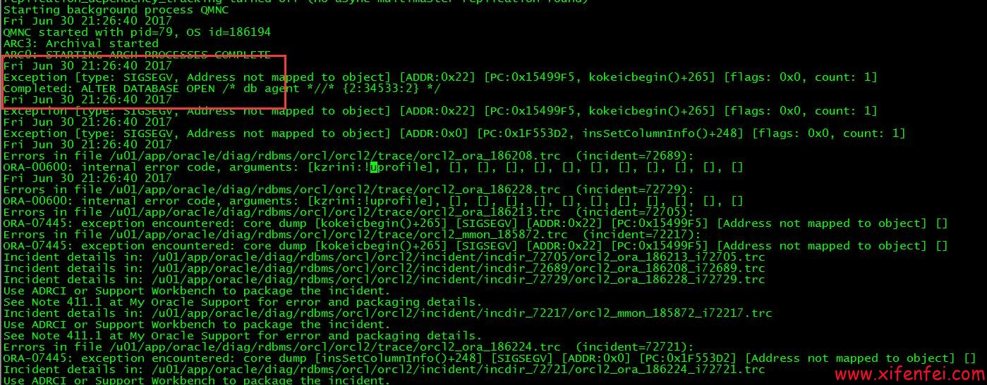](http://www.xifenfei.com/?p=7156)

[](http://www.xifenfei.com/?p=7156)

再次启动数据库直接报ORA-600 16703错误

[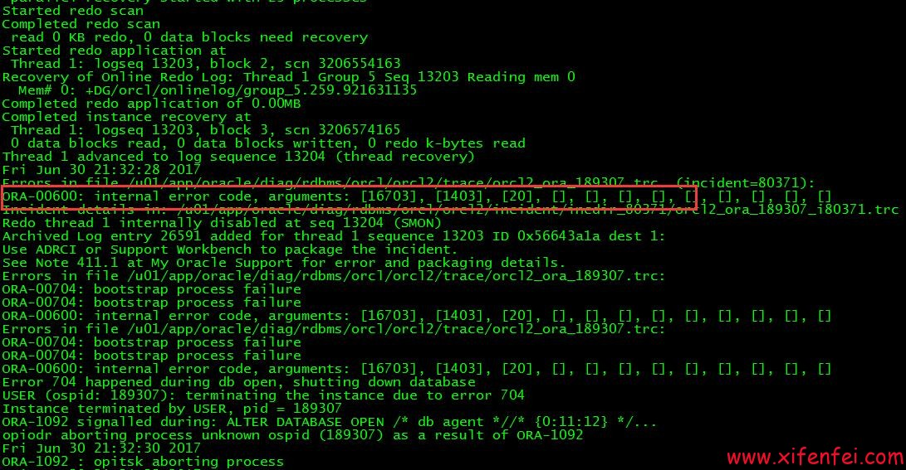](http://www.xifenfei.com/?p=7156)

[](http://www.xifenfei.com/?p=7156)

这里有一个其他现象,就是数据库在open成功的同时(同一秒内),开始报异常.重启之后直接报

ORA-00704: bootstrap process failure

ORA-00704: bootstrap process failure

ORA-00600: internal error code, arguments: [16703], [1403], [20], [], [], [], [], [], [], [], [], []

根据10046分析结果

|  |
| --- |
| =====================  select rowcnt,blkcnt,empcnt,avgspc,chncnt,avgrln,nvl(degree,1), nvl(instances,1) from tab$ where obj# = :1  END OF STMT  PARSE #140048443935120:c=0,e=390,p=0,cr=0,cu=0,mis=1,r=0,dep=1,og=4,plh=0,tim=1499185905161433  =====================  select blevel, leafcnt, distkey, lblkkey, dblkkey, clufac,        nvl(degree,1), nvl(instances,1) from ind$ where bo# = :1 and obj# = :2  END OF STMT  PARSE #140048443934176:c=1000,e=601,p=0,cr=0,cu=0,mis=1,r=0,dep=1,og=4,plh=0,tim=1499185905162088  =====================  PARSING IN CURSOR #140048443933232 len=70 dep=1 uid=0 oct=3 lid=0 tim=1499185905162444 hv=3377894161 ad='84f13d70' sqlid='32d4jrb4pd4sj'  select charsetid, charsetform from col$  where obj# = :1 and col# = :2  END OF STMT  PARSE #140048443933232:c=0,e=294,p=0,cr=0,cu=0,mis=1,r=0,dep=1,og=4,plh=0,tim=1499185905162443  =====================  PARSING IN CURSOR #140048443932288 len=52 dep=1 uid=0 oct=3 lid=0 tim=1499185905247020 hv=429618617 ad='84f0f2d0' sqlid='4krwuz0ctqxdt'  select ctime, mtime, stime from obj$ where obj# = :1  END OF STMT  PARSE #140048443932288:c=0,e=549,p=0,cr=0,cu=0,mis=1,r=0,dep=1,og=4,plh=0,tim=1499185905247019  BINDS #140048443932288:  select blevel, leafcnt, distkey, lblkkey, dblkkey, clufac,        nvl(degree,1), nvl(instances,1) from ind$ where bo# = :1 and obj# = :2  END OF STMT  PARSE #140048443934176:c=1000,e=601,p=0,cr=0,cu=0,mis=1,r=0,dep=1,og=4,plh=0,tim=1499185905162088  =====================  PARSING IN CURSOR #140048443933232 len=70 dep=1 uid=0 oct=3 lid=0 tim=1499185905162444 hv=3377894161 ad='84f13d70' sqlid='32d4jrb4pd4sj'  select charsetid, charsetform from col$  where obj# = :1 and col# = :2  END OF STMT  PARSE #140048443933232:c=0,e=294,p=0,cr=0,cu=0,mis=1,r=0,dep=1,og=4,plh=0,tim=1499185905162443  =====================  PARSING IN CURSOR #140048443932288 len=52 dep=1 uid=0 oct=3 lid=0 tim=1499185905247020 hv=429618617 ad='84f0f2d0' sqlid='4krwuz0ctqxdt'  select ctime, mtime, stime from obj$ where obj# = :1  END OF STMT  PARSE #140048443932288:c=0,e=549,p=0,cr=0,cu=0,mis=1,r=0,dep=1,og=4,plh=0,tim=1499185905247019  BINDS #140048443932288:   Bind#0    oacdty=02 mxl=22(22) mxlc=00 mal=00 scl=00 pre=00    oacflg=00 fl2=0001 frm=00 csi=00 siz=24 off=0    kxsbbbfp=7f5f91b87bd0  bln=22  avl=02  flg=05    value=20  EXEC #140048443932288:c=2000,e=2686,p=0,cr=0,cu=0,mis=1,r=0,dep=1,og=4,plh=1218588913,tim=1499185905249810  WAIT #140048443932288: nam='db file sequential read' ela= 6205 file#=1 block#=337 blocks=1 obj#=36 tim=1499185905256132  WAIT #140048443932288: nam='db file sequential read' ela= 3739 file#=1 block#=338 blocks=1 obj#=36 tim=1499185905266704  WAIT #140048443932288: nam='db file sequential read' ela= 4966 file#=1 block#=241 blocks=1 obj#=18 tim=1499185905271761  FETCH #140048443932288:c=0,e=21976,p=3,cr=3,cu=0,mis=0,r=1,dep=1,og=4,plh=1218588913,tim=1499185905271820  STAT #140048443932288 id=1 cnt=1 pid=0 pos=1 obj=18 op='TABLE ACCESS BY INDEX ROWID OBJ$ (cr=3 pr=3 pw=0 time=21993 us)'  STAT #140048443932288 id=2 cnt=1 pid=1 pos=1 obj=36 op='INDEX RANGE SCAN I\_OBJ1 (cr=2 pr=2 pw=0 time=16923 us)'  CLOSE #140048443932288:c=0,e=63,dep=1,type=0,tim=1499185905271941  BINDS #140048443935120:   Bind#0    oacdty=02 mxl=22(22) mxlc=00 mal=00 scl=00 pre=00    oacflg=08 fl2=0001 frm=00 csi=00 siz=24 off=0    kxsbbbfp=7f5f91c07de8  bln=22  avl=02  flg=05    value=20  EXEC #140048443935120:c=1000,e=795,p=0,cr=0,cu=0,mis=1,r=0,dep=1,og=4,plh=2970138452,tim=1499185905272802  WAIT #140048443935120: nam='db file sequential read' ela= 3197 file#=1 block#=169 blocks=1 obj#=3 tim=1499185905276069  WAIT #140048443935120: nam='db file sequential read' ela= 3459 file#=1 block#=170 blocks=1 obj#=3 tim=1499185905404084  WAIT #140048443935120: nam='db file sequential read' ela= 6358 file#=1 block#=145 blocks=1 obj#=4 tim=1499185905410548  FETCH #140048443935120:c=999,e=137805,p=3,cr=3,cu=0,mis=0,r=0,dep=1,og=4,plh=2970138452,tim=1499185905410635  STAT #140048443935120 id=1 cnt=0 pid=0 pos=1 obj=4 op='TABLE ACCESS CLUSTER TAB$ (cr=3 pr=3 pw=0 time=137810 us)'  STAT #140048443935120 id=2 cnt=1 pid=1 pos=1 obj=3 op='INDEX UNIQUE SCAN I\_OBJ# (cr=2 pr=2 pw=0 time=131330 us)'    \*\*\* 2017-07-05 00:31:46.094  Incident 176395 created, dump file: /oracle/diag/rdbms/orcl/orcl2/incident/incdir\_176395/orcl\_ora\_51261\_i176395.trc  ORA-00600: internal error code, arguments: [16703], [1403], [20], [], [], [], [], [], [], [], [], [] |

以及以往恢复经验和mos,基本上可以确定是由于tab$和obj$记录不匹配导致该问题.而且是obj#=20的记录在tab$和obj$中不匹配.

**分析tab$和obj$记录**

|  |
| --- |
| Data UnLoader: 11.2.0.1.5 - Internal Only - on Wed Jul 05 01:28:53 2017  with 64-bit io functions and the decompression option    Copyright (c) 1994 2017 Bernard van Duijnen All rights reserved.     Strictly Oracle Internal Use Only      Found db\_id = 1334610369  Found db\_name = orcl  DUL> unload table TAB$( OBJ# number, DATAOBJ# number,    2      TS# number, FILE# number, BLOCK# number,    3      BOBJ# number, TAB# number, COLS number, CLUCOLS number,    4      PCTFREE$ ignore, PCTUSED$ ignore, INITRANS ignore, MAXTRANS ignore,    5      FLAGS ignore, AUDIT$ ignore, ROWCNT ignore, BLKCNT ignore,    6      EMPCNT ignore, AVGSPC ignore, CHNCNT ignore, AVGRLN ignore,    7      AVGSPC\_FLB ignore, FLBCNT ignore,    8      ANALYZETIME ignore, SAMPLESIZE ignore,    9      DEGREE ignore, INSTANCES ignore,   10      INTCOLS ignore, KERNELCOLS number, PROPERTY number)   11      cluster  C\_OBJ#(OBJ#)   12      storage ( tablespace 0 segobjno 2 tabno 1 file 1 block 144);  . unloading table                      TAB$       0 rows unloaded  DUL> unload table OBJ$( OBJ# number, DATAOBJ# number, OWNER# number,    2      NAME clean varchar2(30), NAMESPACE ignore, SUBNAME clean varchar2(30),    3      TYPE# number, CTIME ignore, MTIME ignore, STIME ignore,    4      STATUS ignore, REMOTEOWNER ignore, LINKNAME ignore,    5      FLAGS ignore, OID$ hexraw)    6      storage ( tablespace 0 segobjno 18 file 1 block 240);  . unloading table                      OBJ$   89804 rows unloaded  DUL> |

这里可以明确表示tab$无记录,obj$有记录,从而启动的过程出现ORA-600 16703错误可以很好解释.由于数据库启动成功和报错几乎同时进行，以及上面看到的tab$记录不存在的情况，初步怀疑是有startup触发器清空tab$表记录

**工具分析触发器表trigger$**

[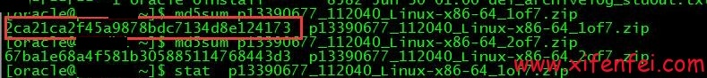](http://www.xifenfei.com/?p=7156)

[](http://www.xifenfei.com/?p=7156)

这里果然看到一个after startup on database的触发器,名字为DBMS\_SUPPORT\_DBMONITOR,而它调用的是DBMS\_SUPPORT\_DBMONITORP存储.

**工具分析pl/sql表source$**

[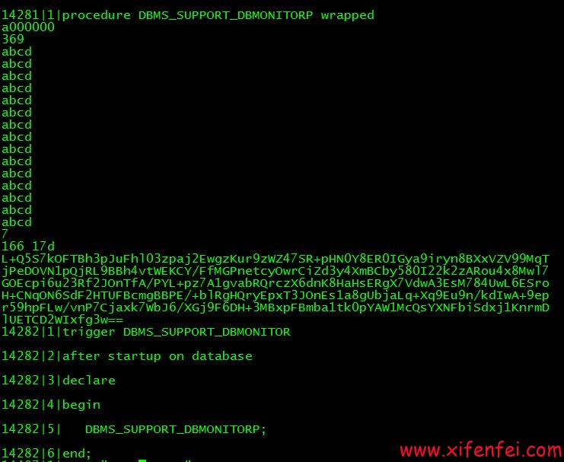](http://www.xifenfei.com/?p=7156)

[](http://www.xifenfei.com/?p=7156)

对wraped加密的程序进行解密

[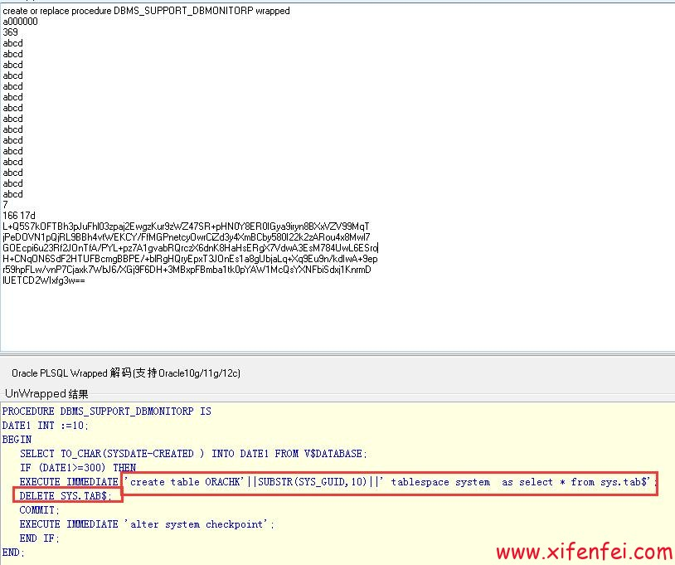](http://www.xifenfei.com/?p=7156)

[](http://www.xifenfei.com/?p=7156)

这里可以明确的看到DBMS\_SUPPORT\_DBMONITORP存储过程备份tab$表到orachk中然后delete tab$表,现在已经明确是由于DBMS\_SUPPORT\_DBMONITOR触发器在数据库重启之后开始执行调用DBMS\_SUPPORT\_DBMONITORP程序,如果判断数据库创建时间大于等于300天,便干掉tab$表,实现数据库破坏.

**查找DBMS\_SUPPORT\_DBMONITOR等程序源头**

分析相关程序创建时间,通过obj$表的ctime和name来判断

[](http://www.xifenfei.com/?p=7156)

[](http://www.xifenfei.com/?p=7156)

[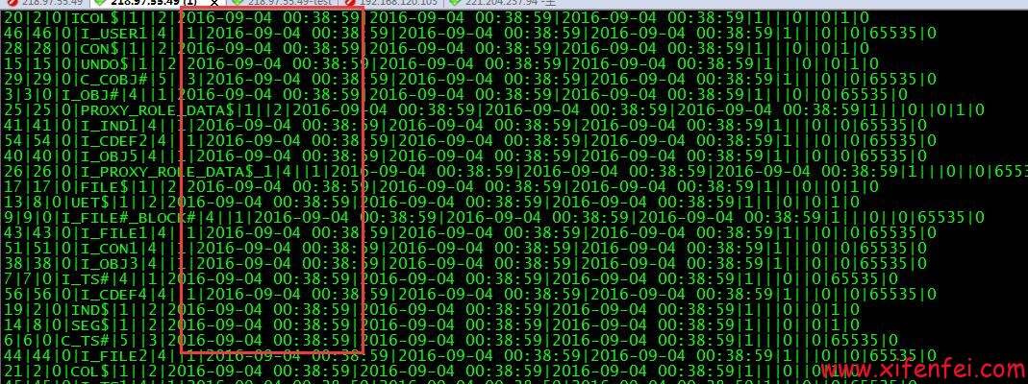](http://www.xifenfei.com/?p=7156)

[](http://www.xifenfei.com/?p=7156)

这里可以看出来DBMS\_SUPPORT\_DBMONITOR和DBMS\_SUPPORT\_DBMONITORP的创建时间基本上和数据库核心对象的创建时间相差无几,我们可以大概排除掉,是由于pl sql等工具连接数据库导致该发问题(类似:[plsql dev引起的数据库被黑勒索比特币实现原理分析和解决方案](http://www.xifenfei.com/2016/11/plsql-dev-hacker-bitcoin.html)),很可能是在dbca创建库的过程中就已经带有了DBMS\_SUPPORT\_DBMONITOR等程序,如果这样那很可能是由于数据库的安装介质被破坏导致该问题.

**分析DBMS\_SUPPORT\_DBMONITOR来源**

[](http://www.xifenfei.com/?p=7156)

[](http://www.xifenfei.com/?p=7156)

[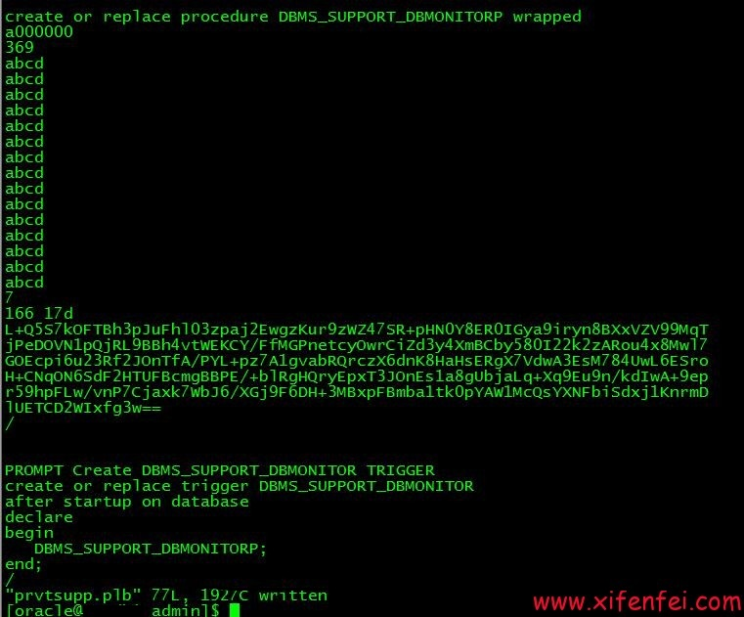](http://www.xifenfei.com/?p=7156)

[](http://www.xifenfei.com/?p=7156)

这里已经很清晰,由于prvtsupp.plb被人注入了恶意脚本从而使得数据库被创建了DBMS\_SUPPORT\_DBMONITOR的触发器和DBMS\_SUPPORT\_DBMONITORP的存储过程,从而实现了对数据库的而易破坏.

**确定破坏文件prvtsupp.plb来源于介质**

[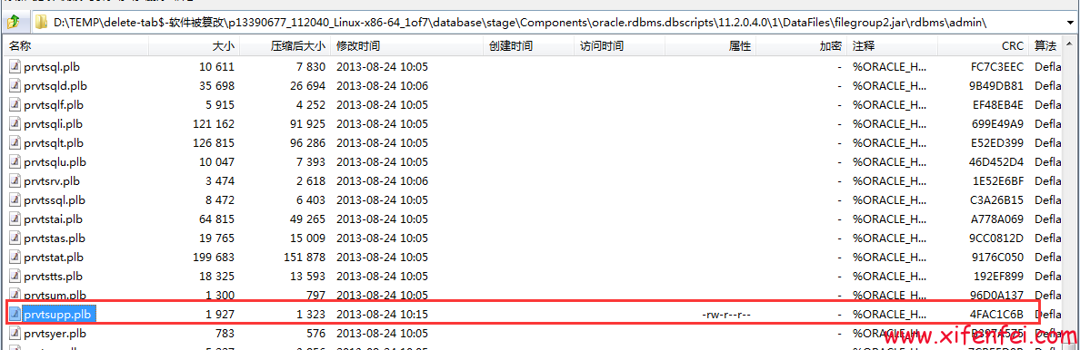](http://www.xifenfei.com/?p=7156)

[](http://www.xifenfei.com/?p=7156)

这里比较明显,文件就是来源database\stage\Components\oracle.rdbms.dbscripts\11.2.0.4.0\1\DataFiles\filegroup2.jar\rdbms\admin\prvtsupp.plb文件被修改导致

[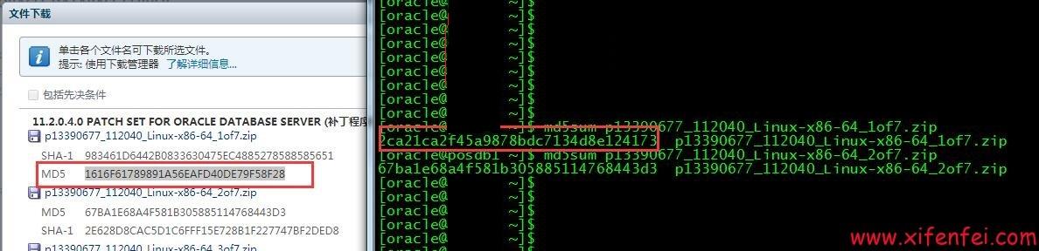](http://www.xifenfei.com/?p=7156)

[](http://www.xifenfei.com/?p=7156)

通过md5码对比,可以确定是有人对软件的安装介质进行了破坏,从而实现了恶意代码的注入,从而实现了数据库300天之后重启之后无法正常启动而是出现类似ORA-00600: internal error code, arguments: [16703], [1403], [20], [], [], [], [], [], [], [], [], []的错误.

**温馨提示**

各位一定要从官方途径下载oracle安装介质,如果是从其他互联网途径下载一定要验证md5,确保文件没有被人恶意篡改,造成无可挽回的损坏.如果真的不幸遇到这类问题,请保护现场联系我们

**<Tel:13429648788>    Q Q:107644445**

[IMG_280](http://wpa.qq.com/msgrd?v=3%26uin=107644445%26site=qq%26menu=yes)

[IMG_281](http://wpa.qq.com/msgrd?v=3%26uin=107644445%26site=qq%26menu=yes)

**E-Mail:[dba@xifenfei.com](mailto:dba@xifenfei.com)**

可以实现业务数据0丢失恢复,最大限度抢救您的数据

来自 <<http://www.xifenfei.com/2017/07/oracle-software-malicious-injection.html>>